**Assignment Array**

1. Store 5 elements in an array and print it.

**Code:**

public class Main1 {

    public static void main(String[] args) {

        int[] array = {1, 2, 3, 4, 5};

        for (int i = 0; i < array.length; i++) {

            System.out.println(array[i]);

        }

    }

}

**Output Screenshot:**

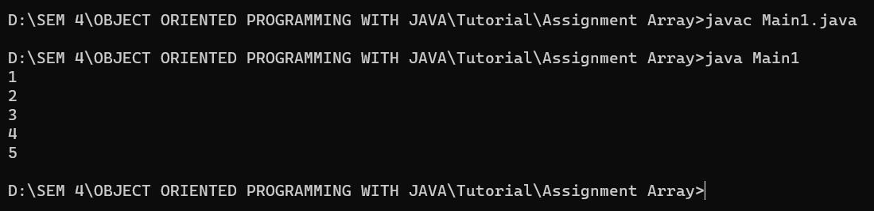

2. Write a program that creates and initializes a four-element byte array. Display its elements.

**Code:**

public class Main2 {

    public static void main(String[] args) {

        byte[] array = { 10, 20, 30, 40 };

        for (int i = 0; i < array.length; i++) {

            System.out.println("Element at index " + i + " : " + array[i]);

        }

    }

}

**Output Screenshot:**

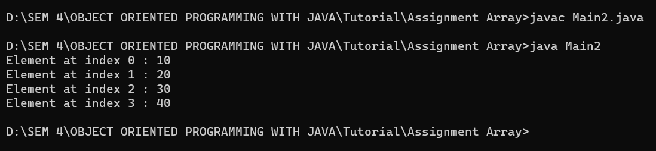

3. Write a program that creates and initializes a four-element double array. Calculate and display the average of its value.

**Code:**

public class Main3 {

    public static void main(String[] args) {

        double[] array = { 1.2, 2.4, 3.6, 4.8 };

        double sum = 0;

        for (int i = 0; i < array.length; i++) {

            sum += array[i];

        }

        double average = sum / array.length;

        System.out.println("The average of the double array is " + average);

    }

}

**Output Screenshot:**

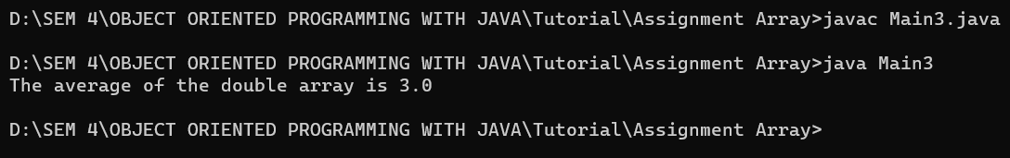

4. Write a program that creates and initializes a ten-element int array. Display length of this array.

**Code:**

public class Main4 {

    public static void main(String[] args) {

        int[] array = { 1, 2, 3, 4, 5, 6, 7, 8, 9, 10 };

        System.out.println("The length of the int array is " + array.length);

    }

}

**Output Screenshot:**

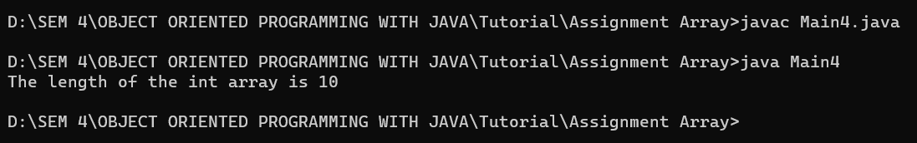

5. Assign a matrix of 3X4 in multidimensional array and print it.

**Code:**

public class Main5 {

    public static void main(String[] args) {

        int[][] matrix = { { 1, 2, 3, 4 }, { 5, 6, 7, 8 }, { 9, 10, 11, 12 } };

        for (int i = 0; i < matrix.length; i++) {

            for (int j = 0; j < matrix[i].length; j++) {

                System.out.print(matrix[i][j] + " ");

            }

            System.out.println();

        }

    }

}

**Output Screenshot:**

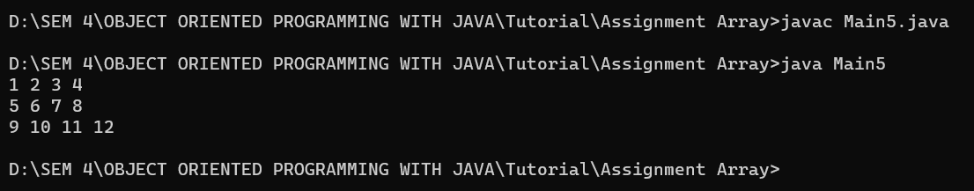

6. Write an application that creates a tow-dimensional array with int values. The first, second, and third elements should be an arrays with one, two, and three numbers, respectively. Display the length of each dimension.

**Code:**

public class Main6 {

    public static void main(String[] args) {

        int[][] array = { { 1 }, { 2, 3 }, { 4, 5, 6 } };

        System.out.println("The length of the first dimension is " + array.length);

        System.out.println("The length of the second dimension is " + array[0].length);

        System.out.println("The length of the third dimension is " + array[1].length);

        System.out.println("The length of the fourth dimension is " + array[2].length);

    }

}

**Output Screenshot:**

